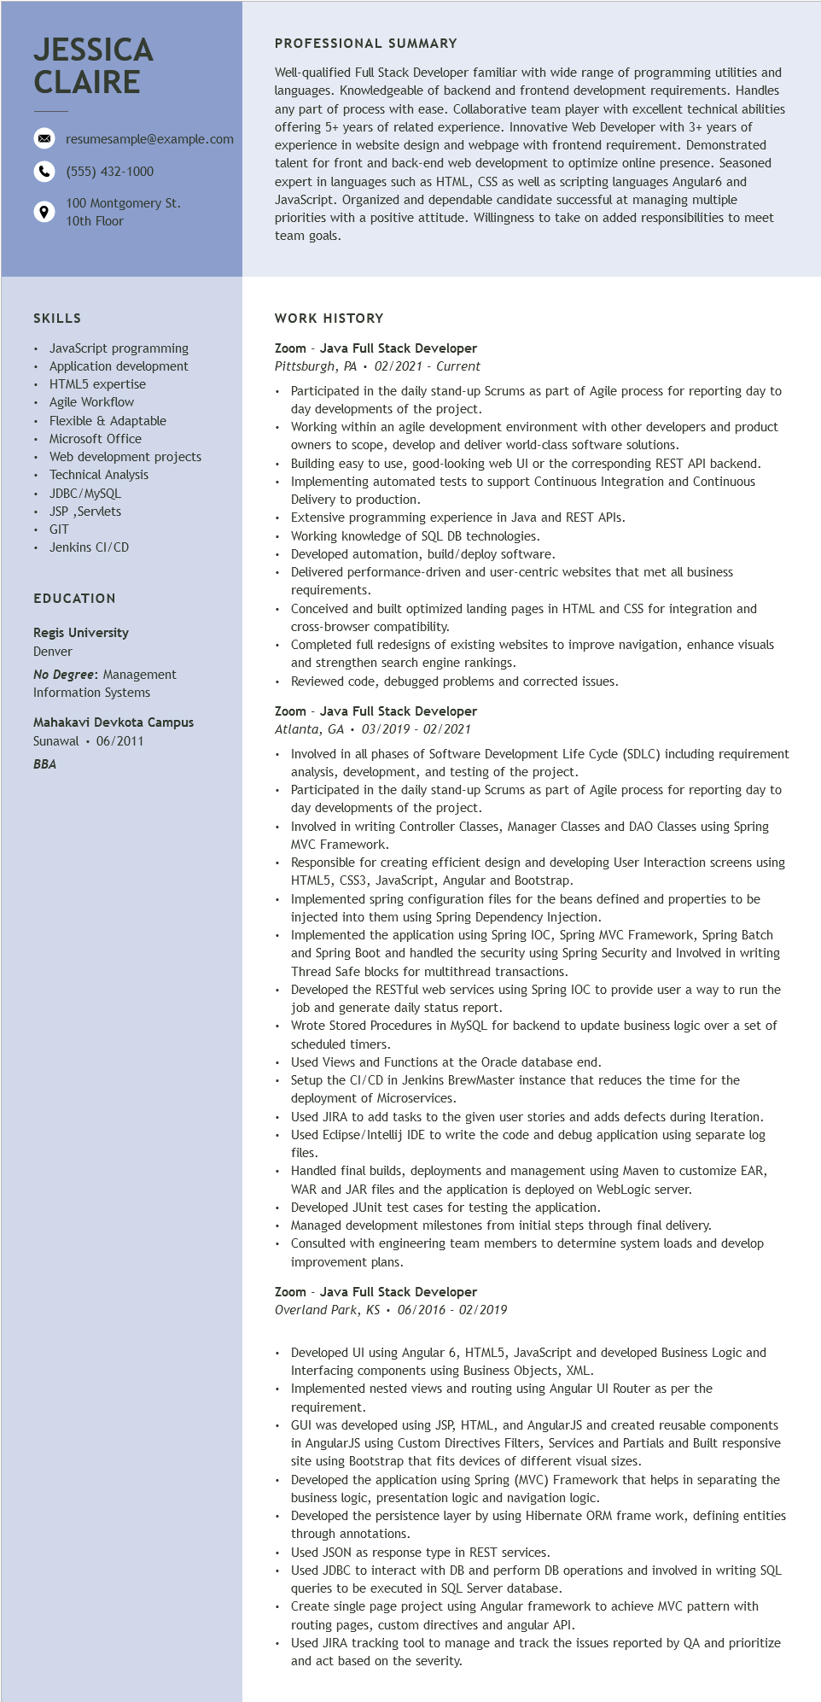
JESSICA CLAIRE
resumesample@example.com (555) 432-1000
100 Montgomery St. 10th Floor
PROFESSIONAL SUMMARY
Well-qualified Full Stack Developer familiar with wide range of programming utilities and languages. Knowledgeable of backend and frontend development requirements. Handles any part of process with ease. Collaborative team player with excellent technical abilities offering 5+ years of related experience. Innovative Web Developer with 3+ years of experience in website design and webpage with frontend requirement. Demonstrated talent for front and back-end web development to optimize online presence. Seasoned expert in languages such as HTML, CSS as well as scripting languages Angular6 and JavaScript. Organized and dependable candidate successful at managing multiple priorities with a positive attitude. Willingness to take on added responsibilities to meet team goals.
SKILLS
• JavaScript programming
• Application development
• HTML5 expertise • Agile Workflow
Flexible & Adaptable
• Microsoft Office
·
Web development projects
Technical Analysis
• JDBC/MySQL
• JSP,Servlets
· GIT
• Jenkins CI/CD
EDUCATION
Regis University Denver
No Degree: Management Information Systems
Mahakavi Devkota Campus
Sunawal 06/2011
BBA
WORK HISTORY
Zoom - Java Full Stack Developer Pittsburgh, PA 02/2021 Current
• Participated in the daily stand-up Scrums as part of Agile process for reporting day to day developments of the project.
Working within an agile development environment with other developers and product owners to scope, develop and deliver world-class software solutions.
Building easy to use, good-looking web UI or the corresponding REST API backend. Implementing automated tests to support Continuous Integration and Continuous Delivery to production.
Extensive programming experience in Java and REST APIs.
• Working knowledge of SQL DB technologies.
• Developed automation, build/deploy software.
• Delivered performance-driven and user-centric websites that met all business requirements.
• Conceived and built optimized landing pages in HTML and CSS for integration and cross-browser compatibility.
• Completed full redesigns of existing websites to improve navigation, enhance visuals and strengthen search engine rankings.
Reviewed code, debugged problems and corrected issues.
Zoom - Java Full Stack Developer
Atlanta, GA 03/2019 - 02/2021
• Involved in all phases of Software Development Life Cycle (SDLC) including requirement analysis, development, and testing of the project.
.
Participated in the daily stand-up Scrums as part of Agile process for reporting day to day developments of the project.
⚫ Involved in writing Controller Classes, Manager Classes and DAO Classes using Spring MVC Framework.
Responsible for creating efficient design and developing User Interaction screens using HTML5, CSS3, JavaScript, Angular and Bootstrap.
• Implemented spring configuration files for the beans defined and properties to be injected into them using Spring Dependency Injection.
• Implemented the application using Spring IOC, Spring MVC Framework, Spring Batch and Spring Boot and handled the security using Spring Security and Involved in writing Thread Safe blocks for multithread transactions.
• Developed the RESTful web services using Spring IOC to provide user a way to run the job and generate daily status report.
Wrote Stored Procedures in MySQL for backend to update business logic over a set of scheduled timers.
• Used Views and Functions at the Oracle database end.
• Setup the CI/CD in Jenkins BrewMaster instance that reduces the time for the deployment of Microservices.
• Used JIRA to add tasks to the given user stories and adds defects during Iteration.
• Used Eclipse/Intellij IDE to write the code and debug application using separate log files.
• Handled final builds, deployments and management using Maven to customize EAR, WAR and JAR files and the application is deployed on WebLogic server.
• Developed JUnit test cases for testing the application.
• Managed development milestones from initial steps through final delivery.
• Consulted with engineering team members to determine system loads and develop improvement plans.
Zoom Java Full Stack Developer
Overland Park, KS 06/2016 - 02/2019
• Developed UI using Angular 6, HTML5, JavaScript and developed Business Logic and Interfacing components using Business Objects, XML.
• Implemented nested views and routing using Angular UI Router as per the
requirement.
• GUI was developed using JSP, HTML, and AngularJS and created reusable components in AngularJS using Custom Directives Filters, Services and Partials and Built responsive site using Bootstrap that fits devices of different visual sizes.
• Developed the application using Spring (MVC) Framework that helps in separating the business logic, presentation logic and navigation logic.
• Developed the persistence layer by using Hibernate ORM frame work, defining entities through annotations.
• Used JSON as response type in REST services.
• Used JDBC to interact with DB and perform DB operations and involved in writing SQL queries to be executed in SQL Server database.
• Create single page project using Angular framework to achieve MVC pattern with
routing pages, custom directives and angular API.
• Used JIRA tracking tool to manage and track the issues reported by QA and prioritize and act based on the severity.

